變色龍

Chameleon

在這個專案裡，你會做出一個能根據背景改變顏色的變色龍

In this project you will make a chameleon that changes colour to match its background.

你會使用網路攝影機拍攝不同顏色的物體，接著利用機器學習搭配這些範例，訓練變色龍辨識不同的顏色

You’ll use a webcam to take photos of different coloured objects, then use machine learning with those examples to train the chameleon to recognise colours.

這個專案的靈感來自Cassie Evans。下面網址收錄她所設計的版本：

The idea for this project came from Cassie Evans. You can see her version of it at

<https://codepen.io/cassie-codes/details/ZjErdL>



This project worksheet is licensed under a Creative Commons Attribution Non-Commercial Share-Alike License

http://creativecommons.org/licenses/by-nc-sa/4.0/

1. 搜尋網頁：<https://machinelearningforkids.co.uk/>

Go to <https://machinelearningforkids.co.uk/> in a web browser

1. 點選“**Get started**”按鈕

Click on “**Get started**”

1. 點選“**Log In**”按鈕並登入系統

Click on “**Log In**” and type in your username and password

*如果你沒有帳號，請你的老師幫你建立一個帳號。*

*如果你不記得你的帳號或密碼，請你的老師幫你重新設定一次。*

*If you don’t have a username, ask your teacher to create one for you.  
If you can’t remember your password, ask your teacher to reset it for you.*

1. 點選上方清單中的 **”Projects”** 按鈕

Click on “**Projects**” on the top menu bar

1. 點選 “**+ Add a new project**” 按鈕

Click the **“+ Add a new project**” button.

1. 將你的專案命名為 “Chameleon”並設定成辨識 “**images**”類別，點選 “**Create**”按鈕

Name your project “chameleon” and set it to learn how to recognise “**images**”. Click the “**Create**” button  
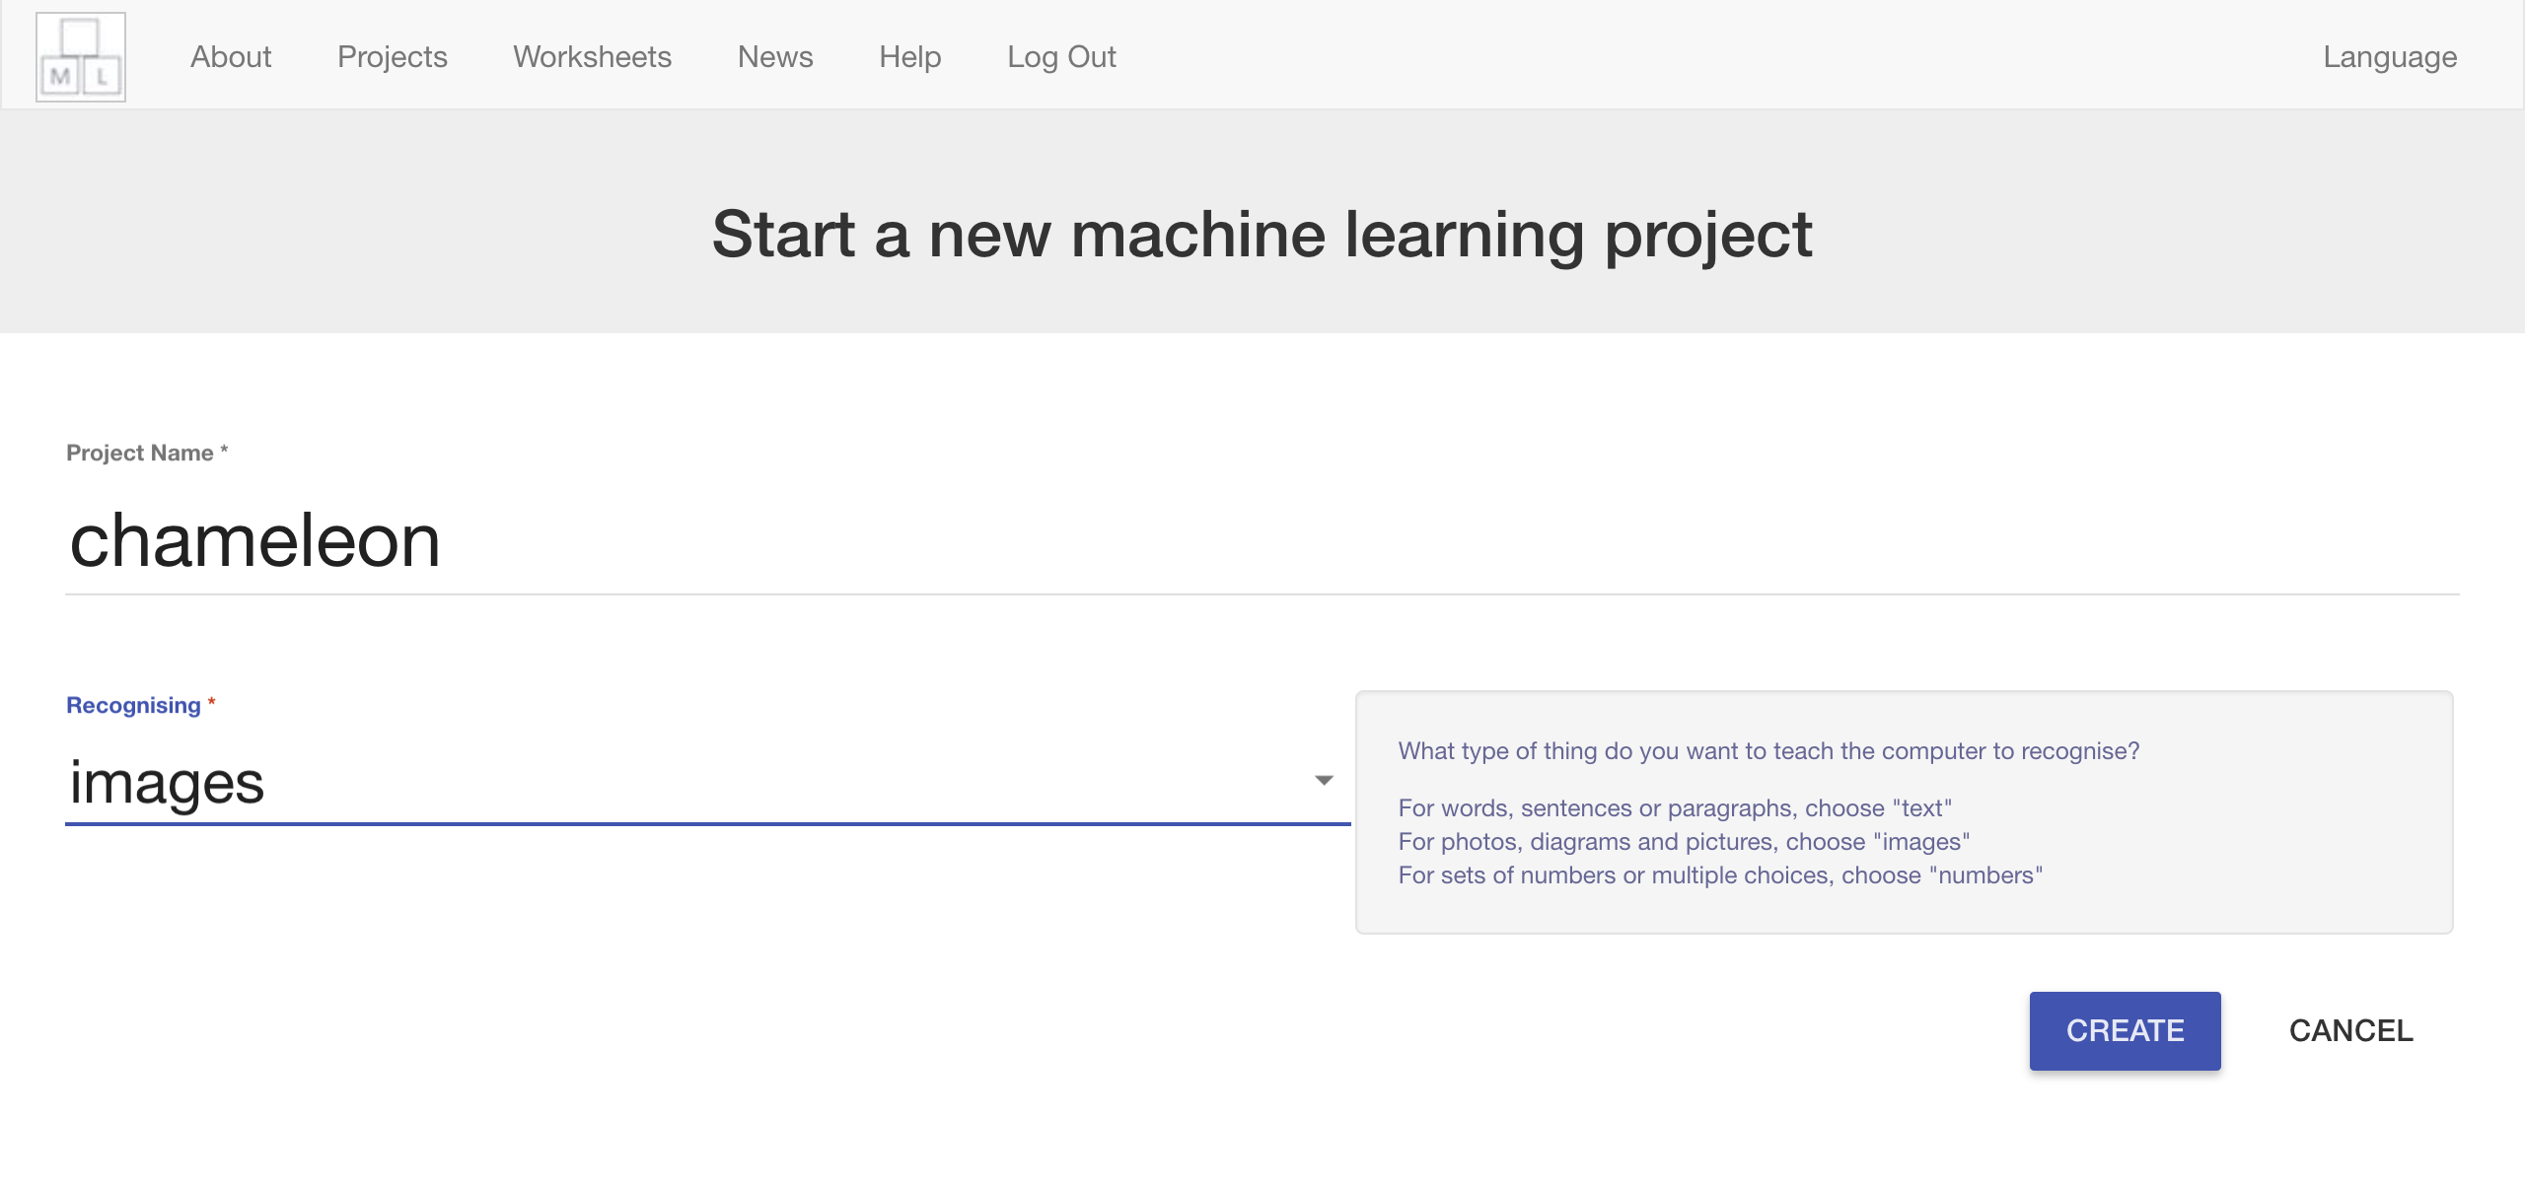

1. 你會在專案清單中看到“**chameleon**”，點選此專案

You should see “**chameleon**” in the list of your projects. Click on it.  
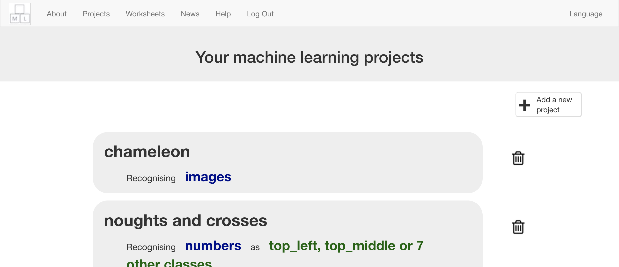

1. 點選 **”Train”** 按鈕

Click the **Train** button  
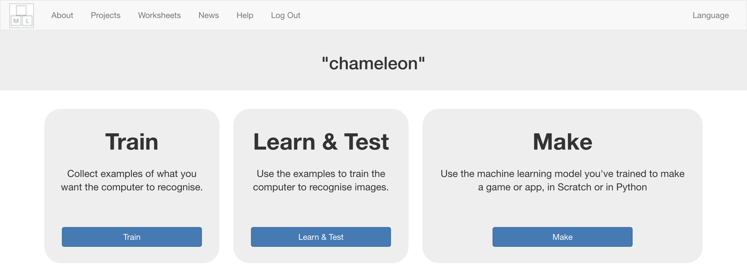

1. 選擇三種顏色

Choose three colours  
*盡量選擇你容易找到的顏色。在這份學習單中，我會使用紅色、綠色以及藍色。*

*Choose colours that you’ll easily be able to find. For the rest of this worksheet, I’ll be using red, green, and blue.*

1. 點選 “**+ Add new label**”按鈕 Click “**+ Add new label**”  
   
2. 輸入第一種顏色名稱，並點選 “**Add**”

Type in the name of your first colour, and press **Add**

1. 輸入剩下的兩種顏色

Do that again for your other two colours  
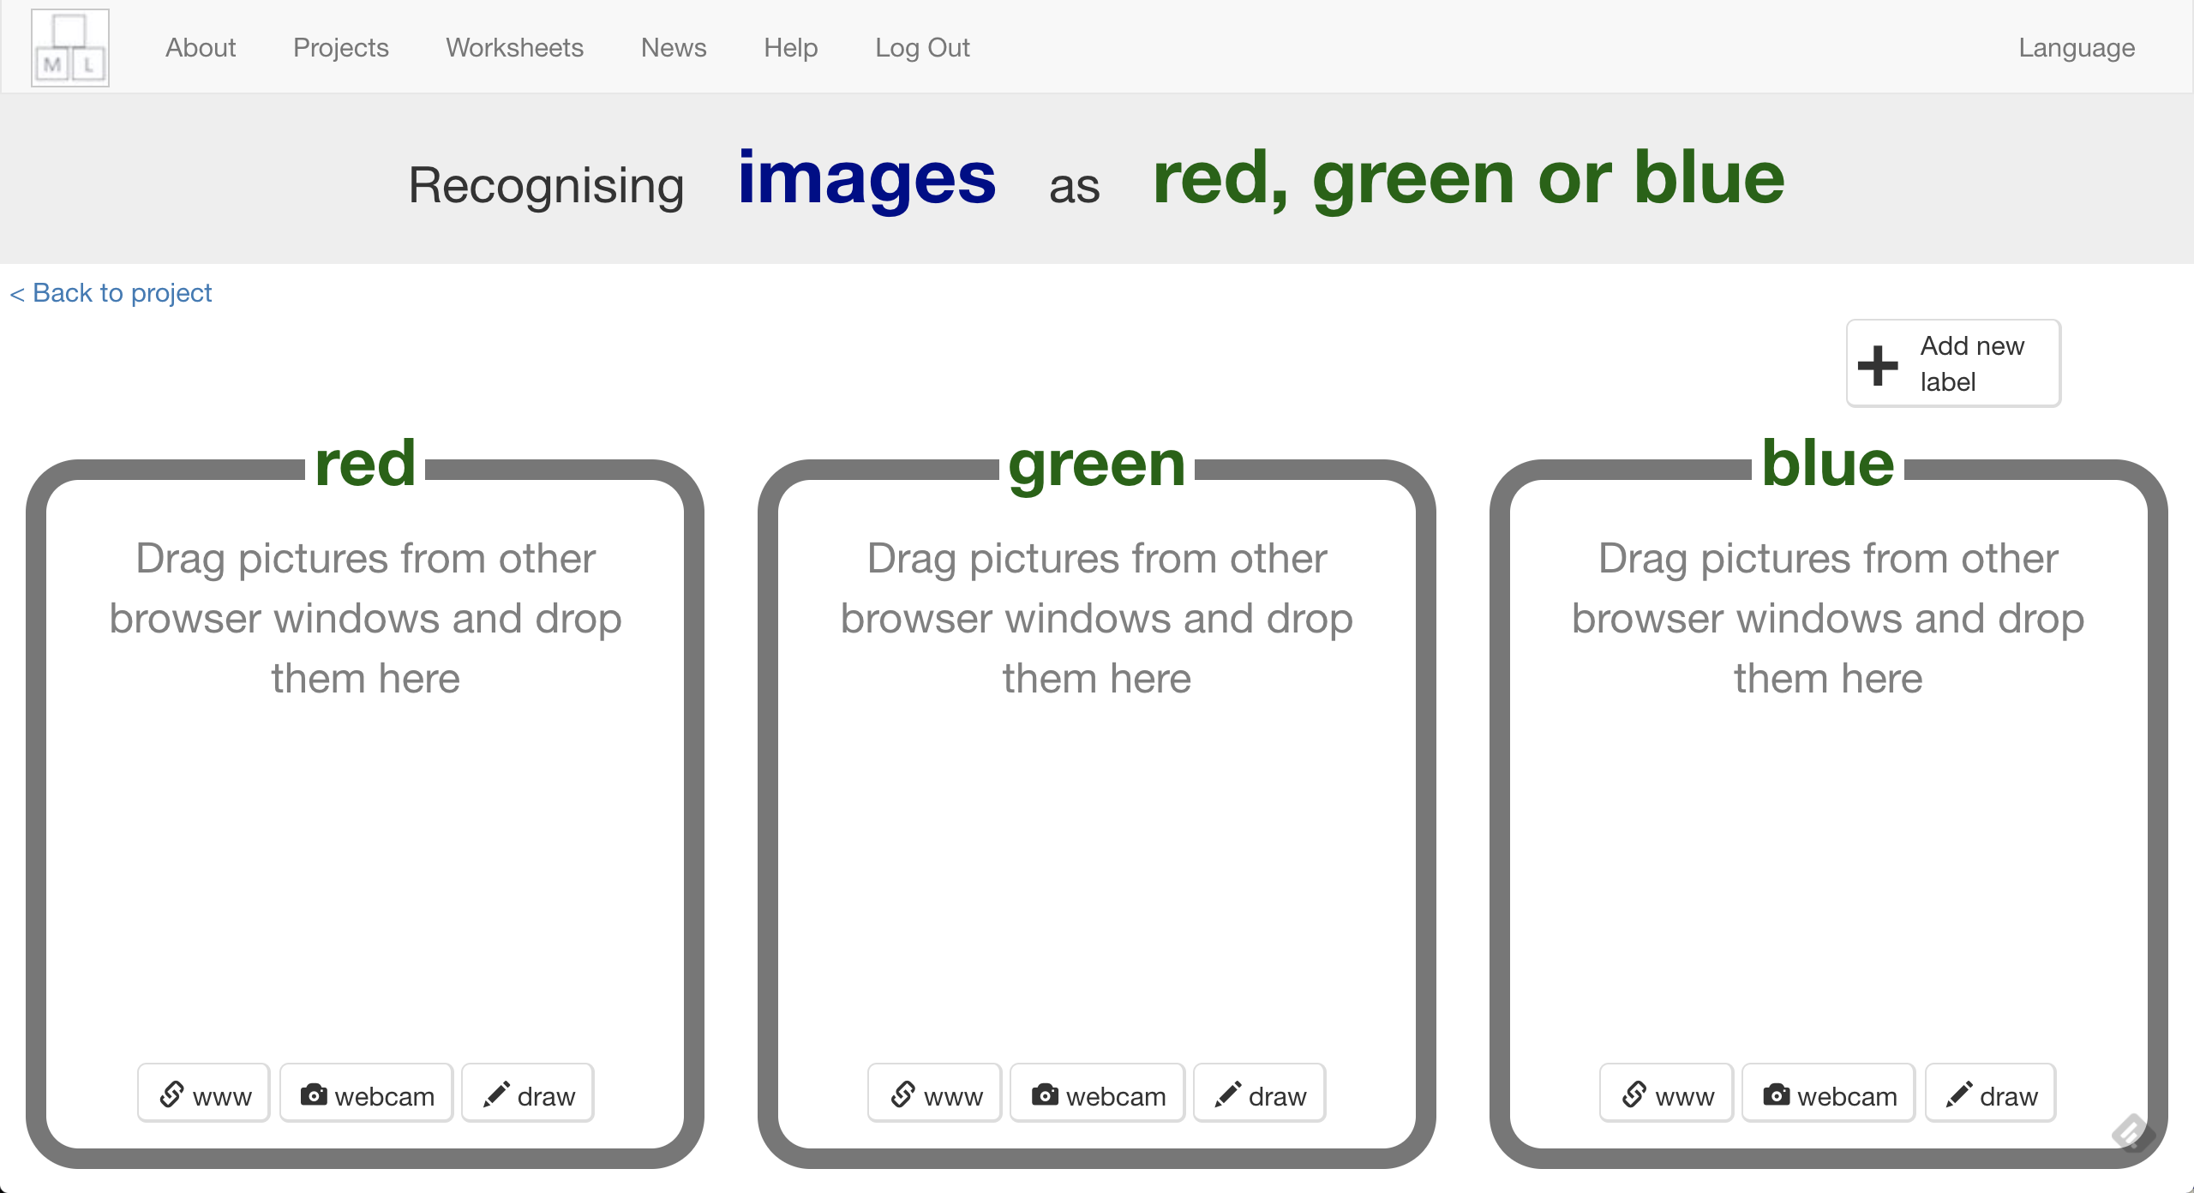

1. 點選第一個顏色框裡的攝影機圖案

Click on the webcam button in your first colour bucket  
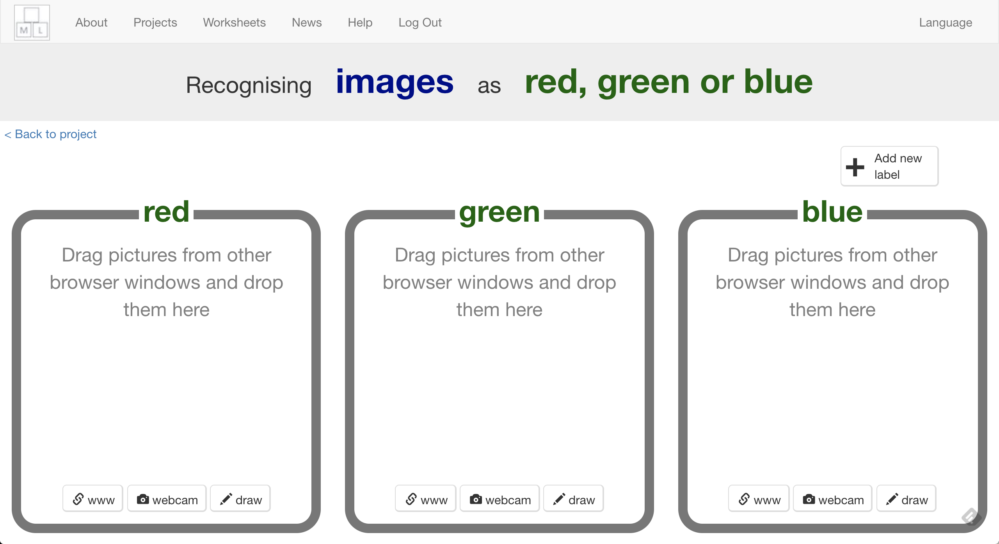

1. 拍一些這個顏色的物品

Take a photo of something that is that colour   
*試著多拍一些照片*

*Try to fill a lot of the picture*

1. 重複上個步驟直到每個顏色都有**10張**範例照片

Repeat until you’ve got **ten examples** in each colour  
*盡量拍攝不同的物品。如果找不到夠多種類，那就從不同角度或由下往上拍*

*Try to find different objects for each colour. If that’s not possible, take more than one picture of things from different angles or upside-down*

1. 點選“**< Back to project**”

Click “**< Back to project**”

1. 點選 “**Learn & Test**”

Click **Learn & Test**

1. 點選“**Train new machine learning model**”按鈕

Click the “**Train new machine learning model**” button  
*此步驟可能需要花費幾分鐘的時間*

*It might take a few minutes for the model to train.*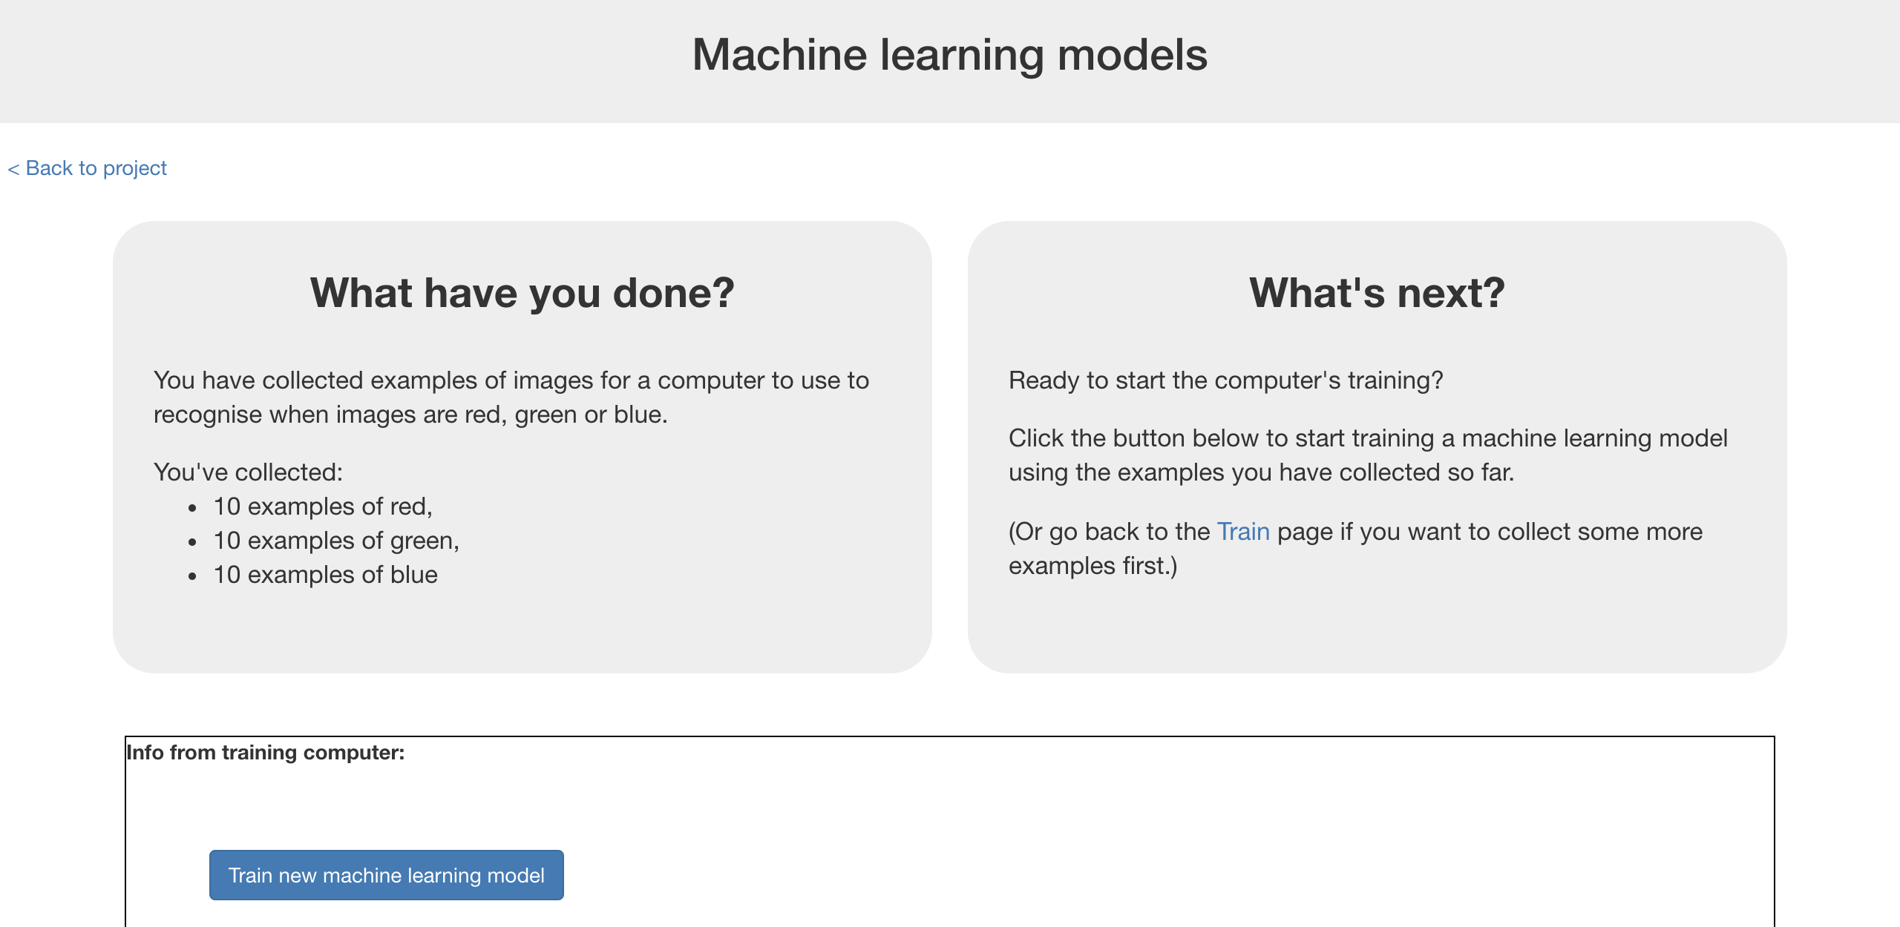

**到目前為止，你做了哪些事情？**

**What have you done so far?**

你蒐集範例照片來訓練電腦分辨照片的顏色。這些範例會被用來訓練一個機器學習的 『模型』。

You’ve started to train a computer to recognise colour of a picture. You are doing it by taking example photos. These examples are being used to train a machine learning “model”.

這就是所謂的『監督式學習』，因為你在這個過程中確保（監督）電腦收到的結果是正確的(supervised learning)。

This is called “supervised learning” because of the way you are supervising the computer’s training.

電腦會從你給的範例照片的顏色裡學習到一些模式。這些東西會被用來辨識新的照片。

The computer will learn from patterns in the colours from each of the photos you’ve given it. These will be used to recognise new photos.

1. 點選“**< Back to project**”

Click “**< Back to project**”

1. 點選“**Make**”按鈕

Click the “**Make**” button

1. 點選“**Scratch**”

Click “**Scratch**”

1. 點選**Open in Scratch**

Click on **Open in Scratch**  
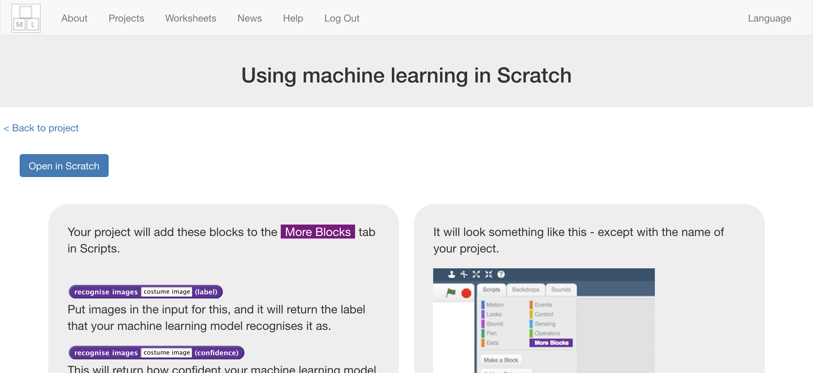

1. 你可以在專案裡的『更多積木』(More blocks)區看到新積木

You should see blocks in “**More blocks**” from your project.  
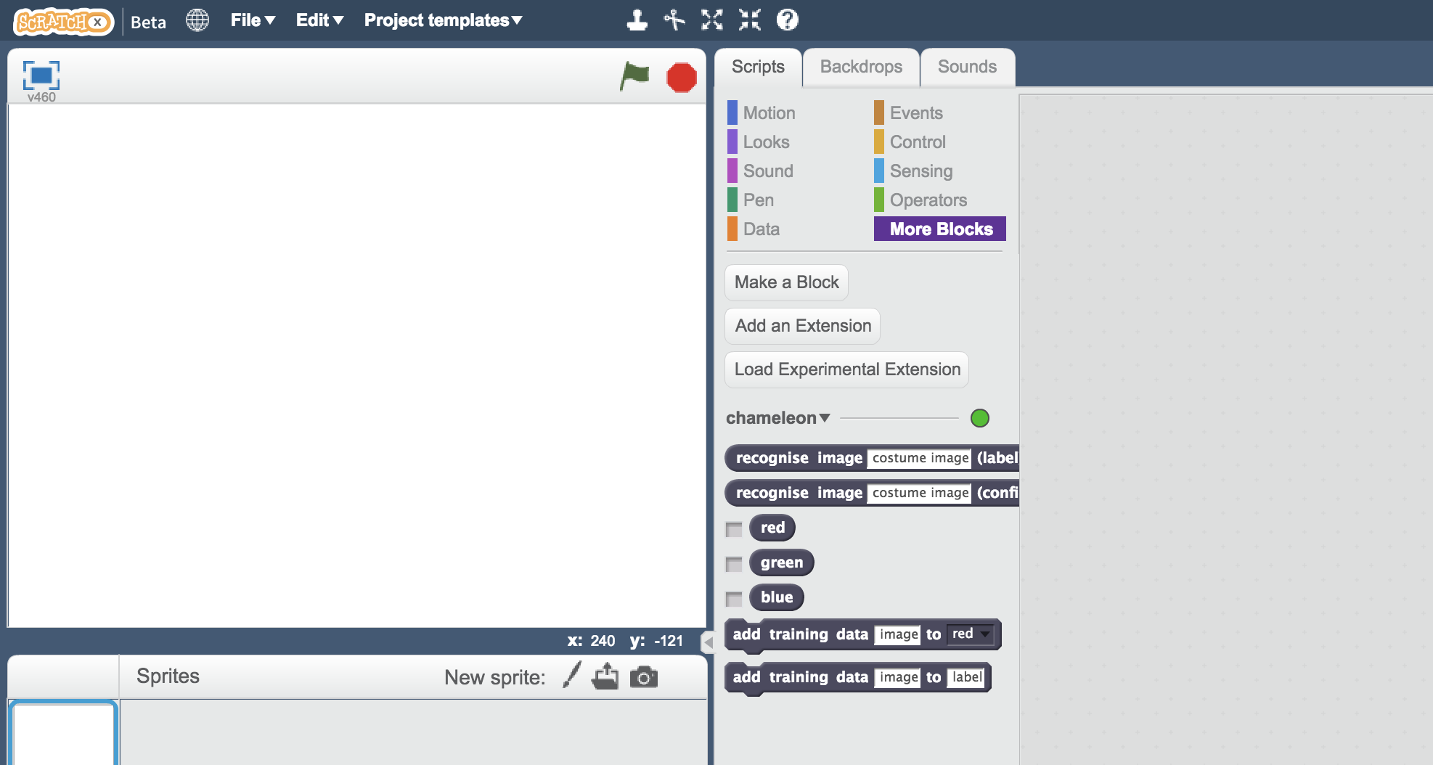

1. 點選***Project templates，***再點選***Chameleon***

Open the project template  
*Click on* ***Project templates*** *->* ***Chameleon***

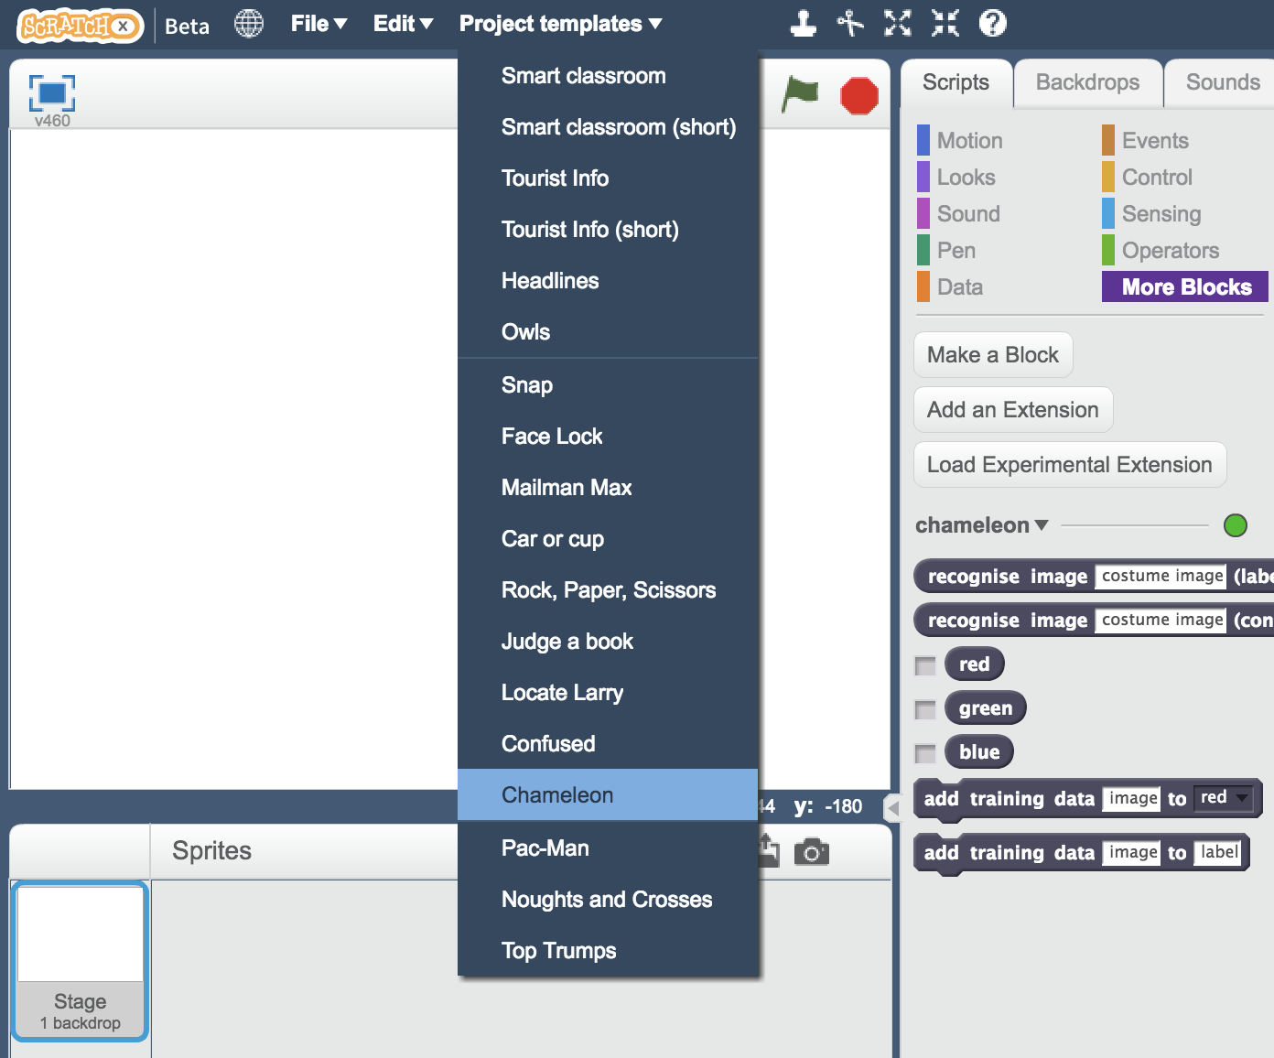

1. 點選『造型』

Click on the **Costumes** tab  
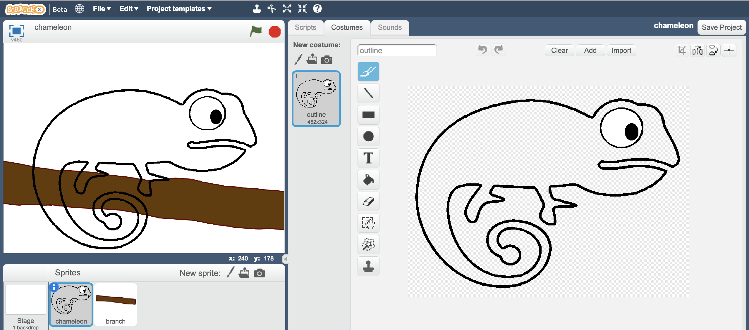

1. 在角色上按右鍵，並點選『複製』

Right-click on the “**outline**” costume, and click “**duplicate**”  
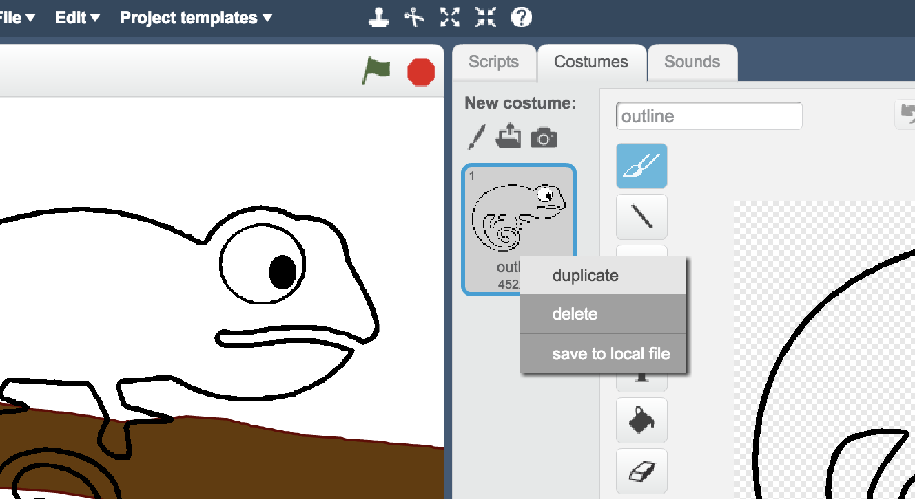

1. 將複製的角色命名為你選擇的第一種顏色

Name the duplicate costume the name of the first of your colours  
*角色名稱必須和顏色的拼法一模一樣，否則之後無法正確執行*

*It’s very important that the name matches exactly, or your script won’t work.*  
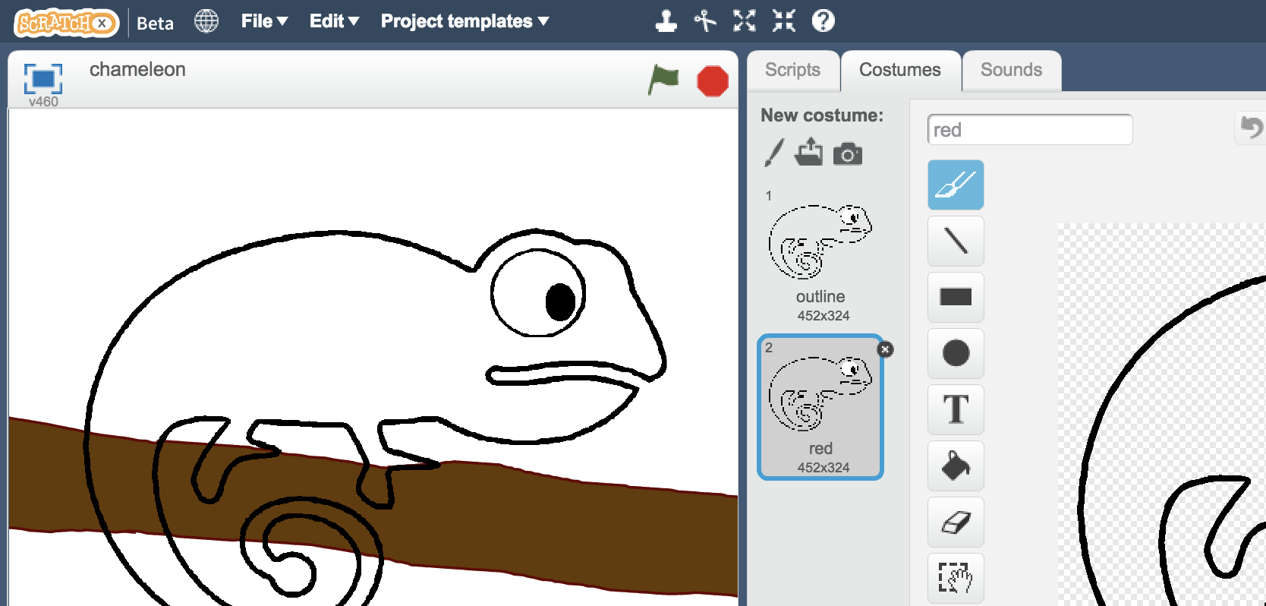

1. 使用填色功能為變色龍上色

Use the **paint fill tool** to colour in the chameleon costume  
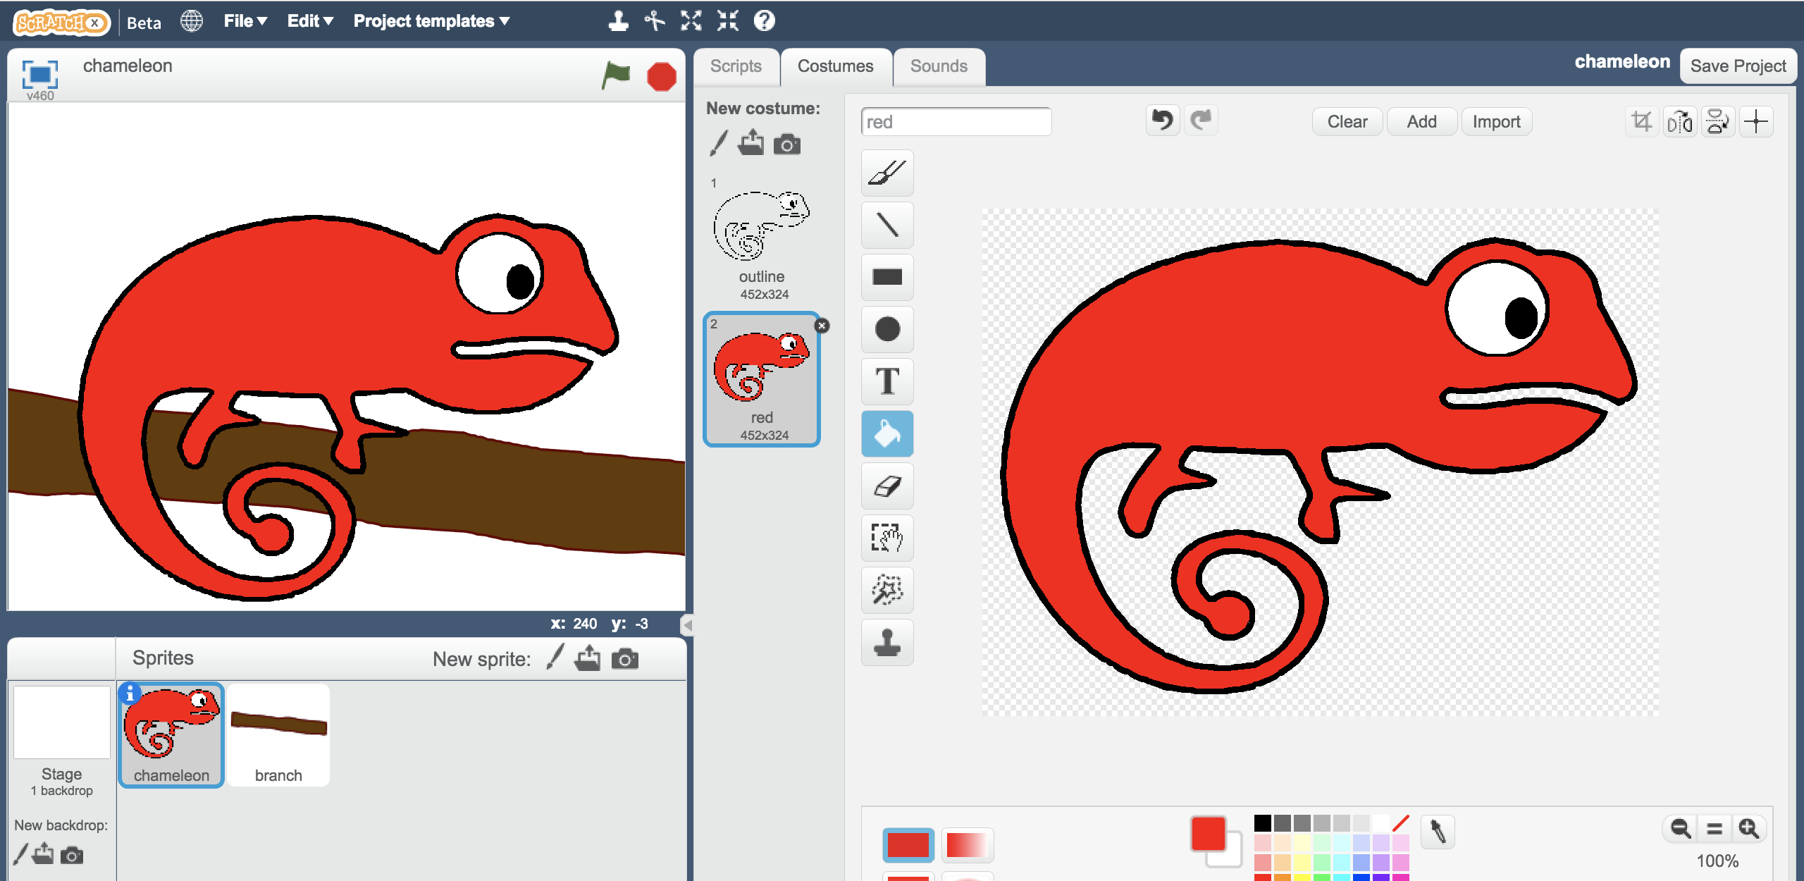

1. 重複上面的步驟，複製角色、重新命名，並將變色龍填上第二種顏色

Repeat. Duplicate the outline costume again, name it after the second of your colours, and colour it in  
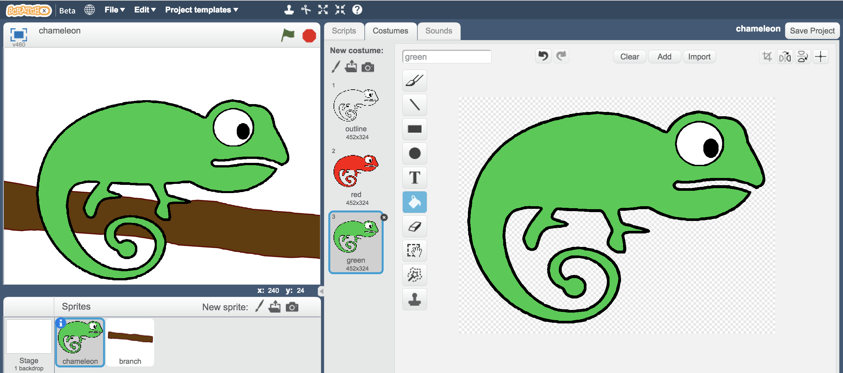

1. 再次重複上述步驟，複製、命名、填色第三隻變色龍

Repeat again to get the third colour costume  
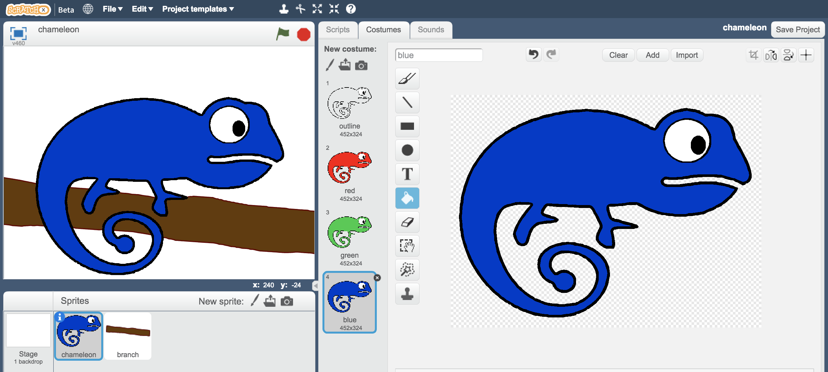

1. 點選『舞台』

Click on the **Stage**  
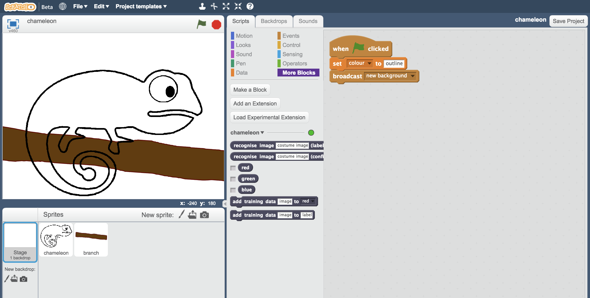

1. 拖曳程式積木（如下圖）

Change the script (that is there already) so it matches this   
*這些程式碼的功用為辨識背影顏色，並傳送一個『事件』，讓變色龍知道應該要變成什麼顏色*

*This will recognise the colour of the background, then send an event to let the chameleon know what colour it should change to.*  
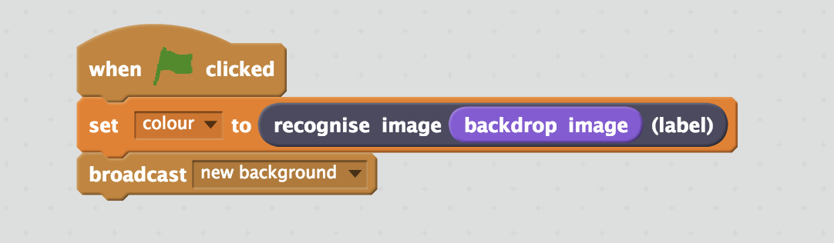

1. 存檔

Save your project  
*點選檔案，再點選儲存專案*

*Click* ***File*** *->* ***Save Project***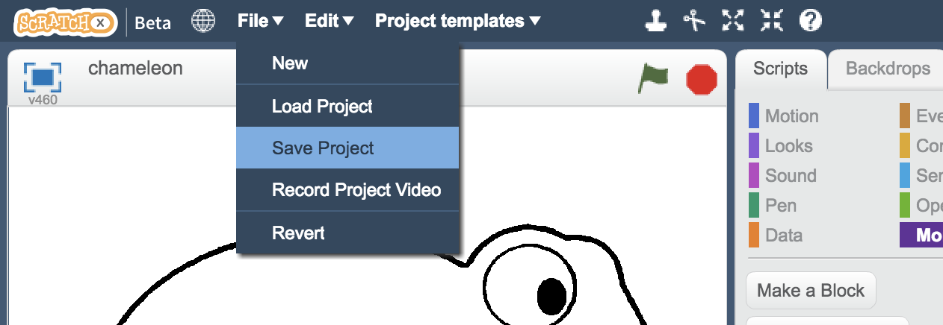

1. 點選舞台的『背景』

Click on the **Backdrops** tab  
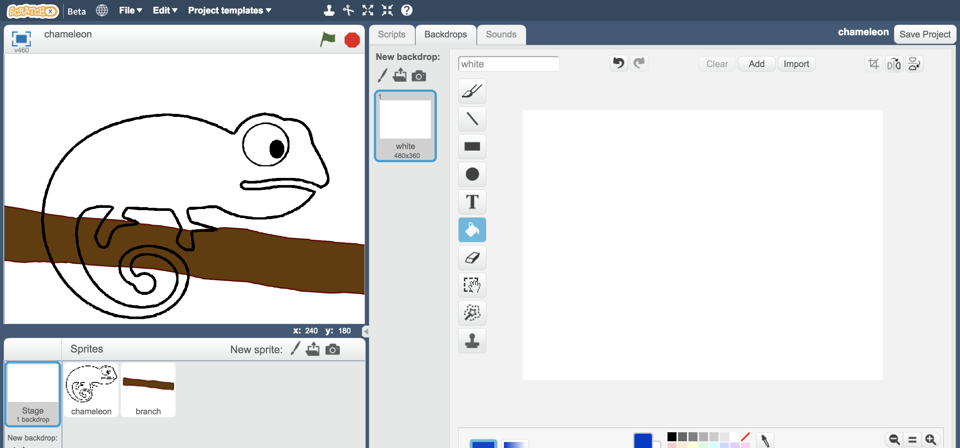

1. 點選 『從攝影裝置錄製新背景』

Click the **New backdrop from camera** button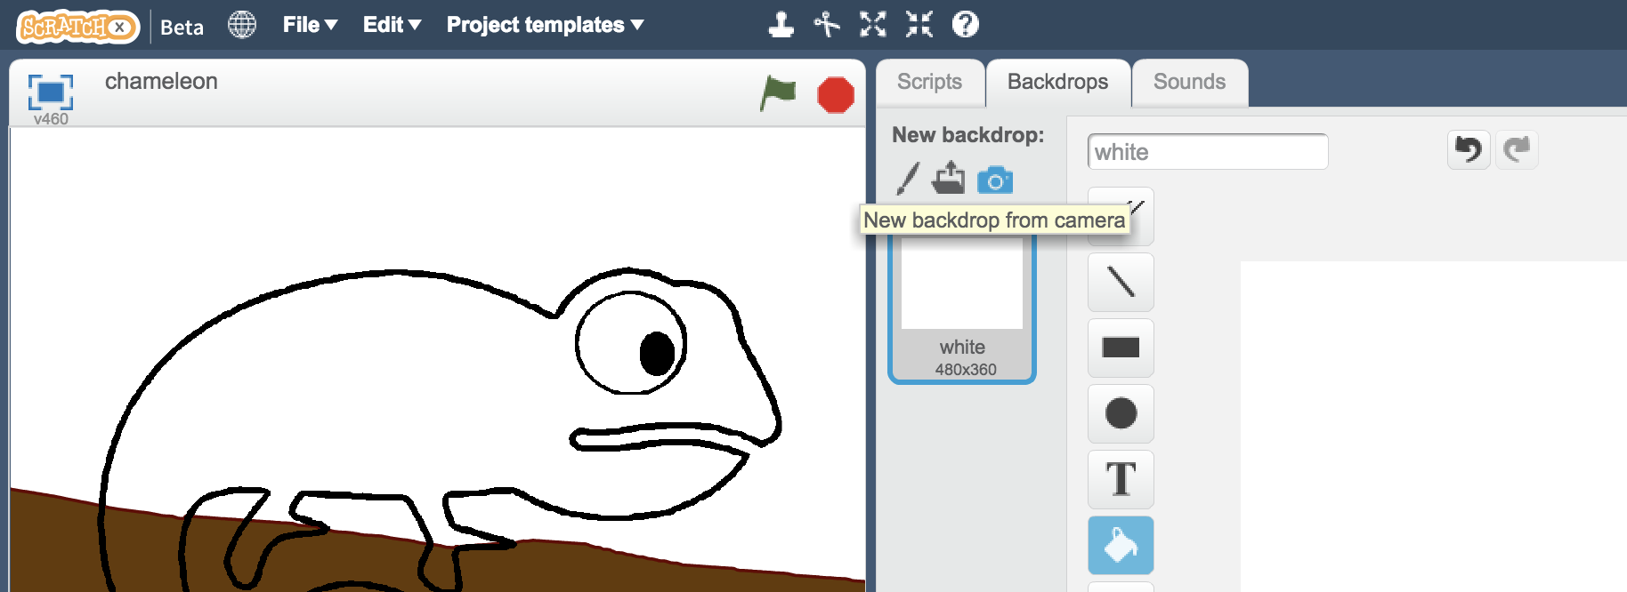

1. 拍攝照片，給變色龍一個新的背景

Take a photo to give the chameleon a new background  
*盡量拍攝非先前用來訓練電腦的範例物品*

*Try to take a photo of something different that you didn’t use to train your machine learning model.*  
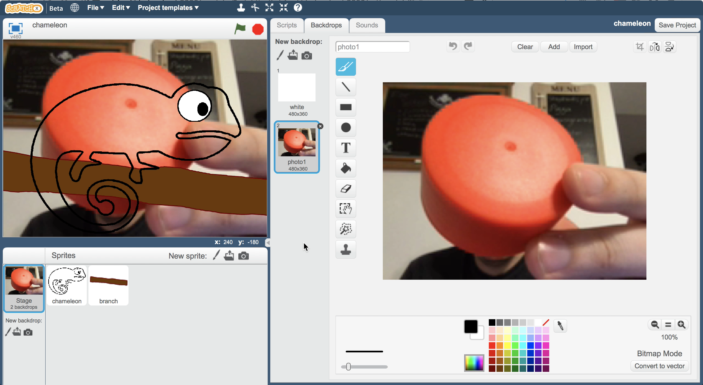

1. 點選綠旗

Click on the **Green Flag***變色龍應該會變成背景物品的顏色喔！*

*The chameleon should change to the colour of the object in the background.  
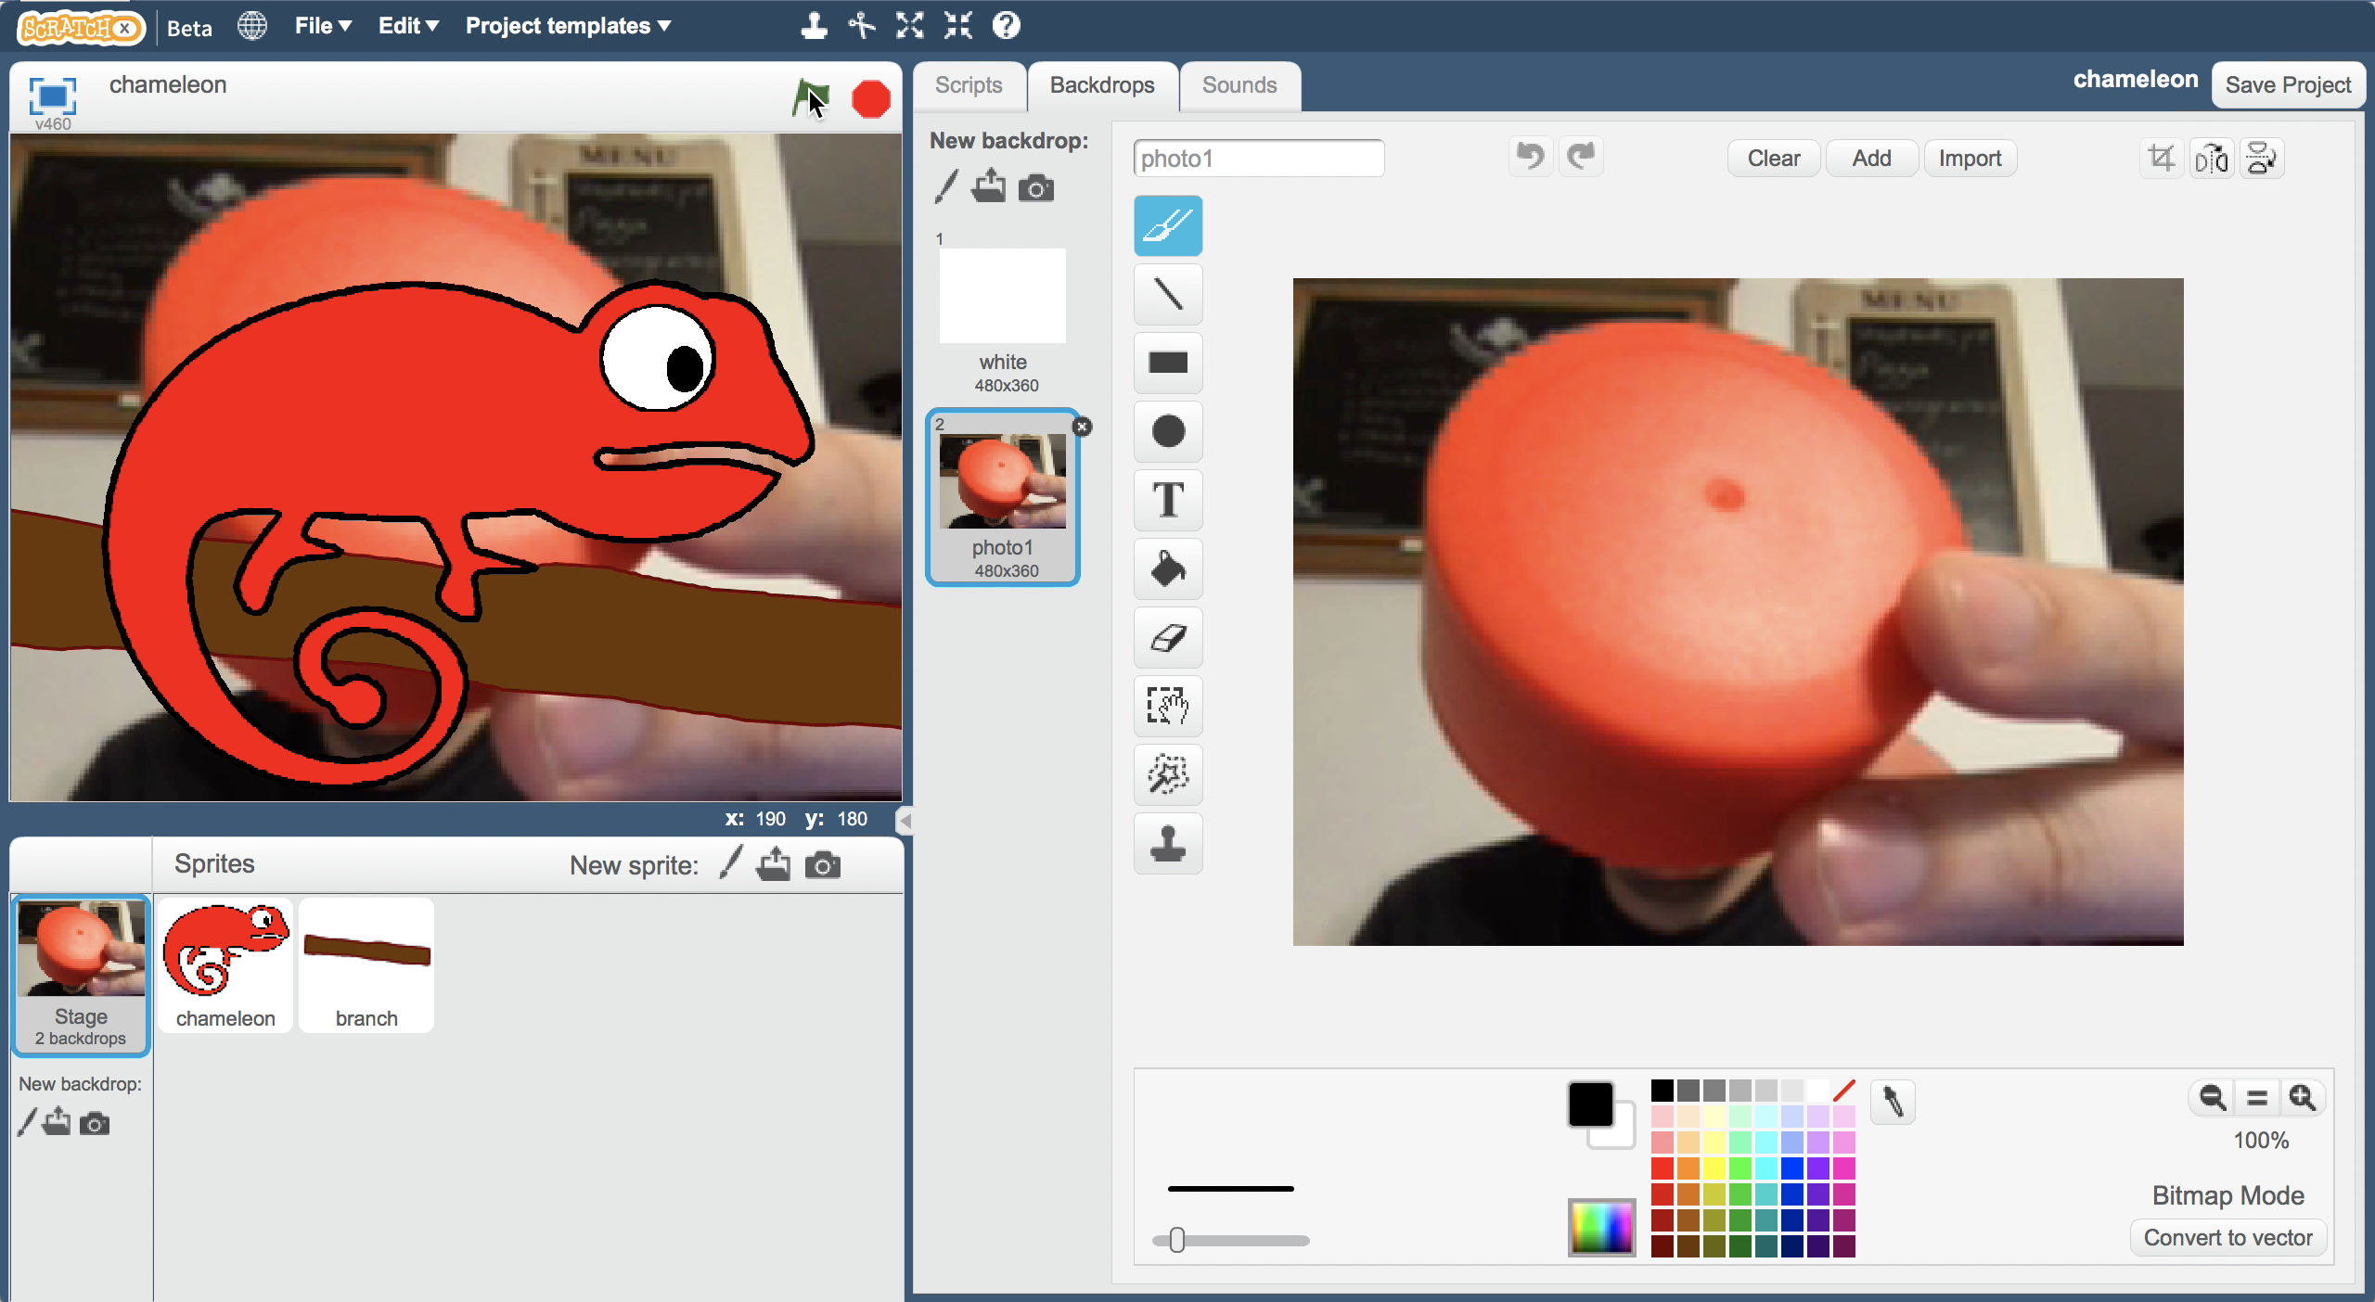*

**你完成了什麼？**

**What have you done?**

你在Scratch中創造了一隻變色龍，他使用機器學習的方式來辨識背景的顏色，並且根據背景改變自己的顏色。

You’ve created a chameleon in Scratch that uses machine learning to recognise the colour of the backdrop, and uses that to switch the costume to match.

當你給了越多範例，電腦辨識顏色的正確率會越高

The more examples you give it, the better it should get at recognising colours correctly.

**延伸活動**

**Ideas and Extensions**

現在你已經完成了這個專案，要不要試試下面的點子？或者，自己想一個？

Now that you’ve finished, why not give one of these ideas a try?

Or come up with one of your own?

**設計你的變色龍**

**Style your chameleon**

你可以擁有一隻不呆板的變色龍。試著設計屬於你自己的保護色

You don’t have to have a plain chameleon. Why not try designing your own camouflage styles?  
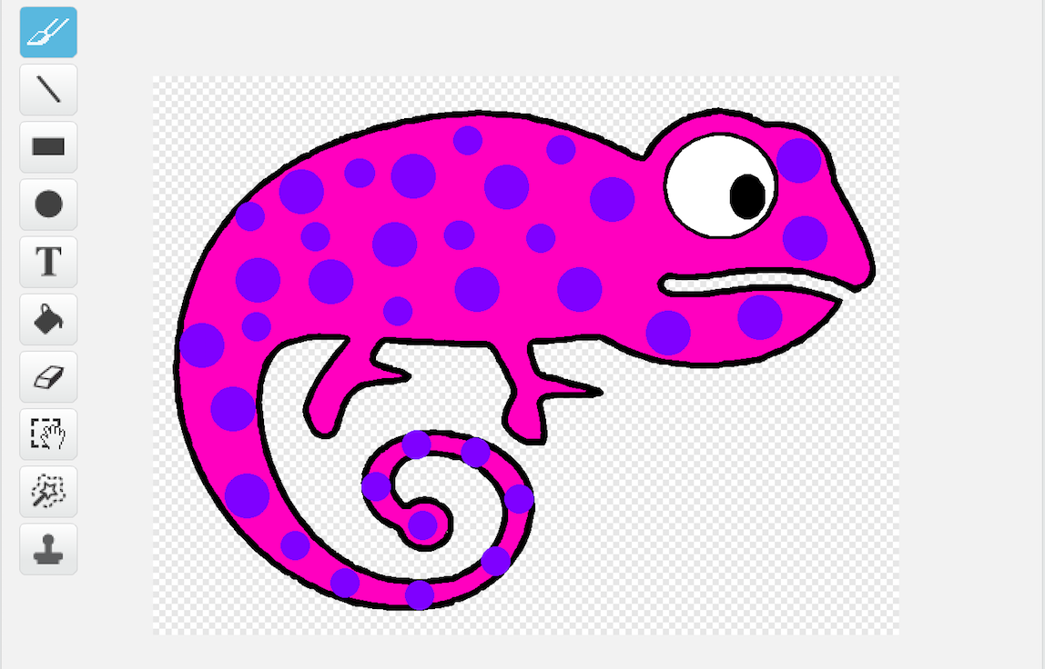

**調皮的變色龍**

**Cheeky chameleon**

在訓練資料中加入第四個框框，裡面放的是10張你吐舌頭的照片。

Try adding a fourth bucket to your training data, with ten photos of you sticking your tongue out.

新增一隻變色龍的角色，並幫他畫出吐舌頭的樣子  
Add another costume of the chameleon and draw on a tongue sticking out.

當機器學習模型偵測到你吐舌頭時，螢幕上的變色龍也會跟著吐舌頭！

When the machine learning model recognises you sticking your tongue out, you can switch to this costume, so your chameleon sticks out its tongue too!